Clinky the Robot:
Preliminary Programming for Preschoolers

Panagis (Pano) Papadatos, Mona Leigh Guha, Tamara Clegg
Human-Computer Interaction Lab
Contact: {squawk, tclegg}@ umd.edu; mona @ cs.umd.edu
www.heypano.com/Clinky

Very young children are often left out of consideration in Computer Science learning. However, developing programming skills early on is possible and extremely beneficial, especially since they are necessary to fully harness the power of computers [1, 2, 3, 4].
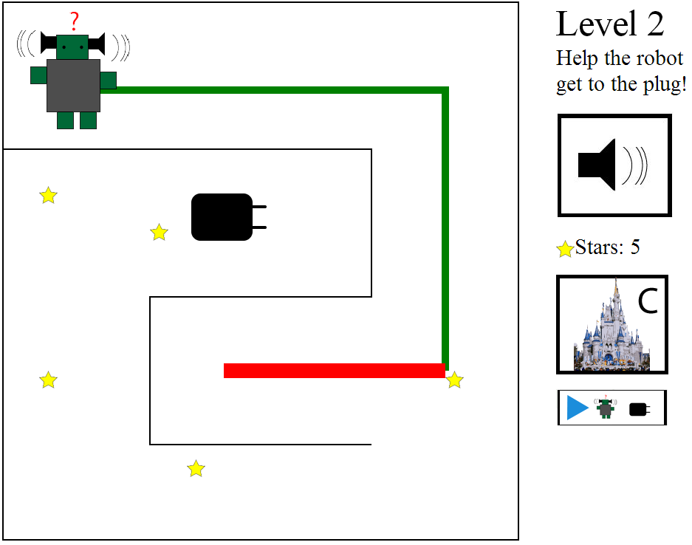
Figure 1 – Clinky is asking the player to help him debug his program.

Mobile touch screen technologies are currently dominating our lives, and especially the lives of children, since they provide a more fluid and pleasurable experience compared to most other types of interfaces [5, 6]. The objective of this project was to design and implement a touch screen application that will help young children (ages 3-5) develop skills that are integral to programming. The application also helps children in developing computational thinking (CT) skills, which are widely considered to be a valuable asset. Furthermore, the process of designing this application can provide a foundation for other designers and perhaps knowledge useful for researchers trying to create similar products or study similar subjects.
In the past 10 years, there have been several attempts to create games or otherwise educational environments that encourage children to acquire CT skills. However, most of these tools focus on children that are older than 5 and do not specifically examine the implications of implementing such an application on a touch screen.

Clinky the Robot
The iPad application we developed is a game that consists of 5 levels (1 introductory and 4 progressive), a “Castle and Shop” and a “Replay Hall”. The player interacts with Clinky, a robot, who is running out of power and needs help getting back to his plug. Throughout the levels, the player is asked to program Clinky in different ways in order to guide him. As a motivation, the player collects stars that can be used to buy upgrades for Clinky and his castle.
In the process of designing this application, we conducted participatory design sessions with children (ages 7-11) and formative evaluation sessions with preschool teachers and children (ages 3-5). We describe the research and methods used in the process of designing this application, demonstrate the application and discuss the findings.

Accompanying DEMO
http://heypano.github.io/Capstone/

PAPERS
- Panagis Papadatos, Mona Leigh Guha, Tamara Clegg. Designing a touch screen application to help young children develop programming skills. HCIM Capstone. (2013).

